DOVER ATHLETIC SUPPORTERS’ CLUB

DASC WEBSITE www.dafcsc.co.uk EMAIL sc.dafc@gmail.com

NEWSLETTER NO.2 SEASON 2024/25

FEBRUARY 2025

***Welcome to our 2nd Newsletter of the Season. Details of our remaining fixtures & our upcoming events***

**Our Continued Support of DAFC, DACT and Other Charities**

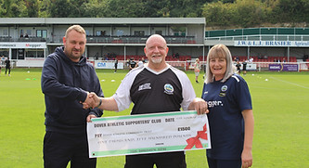One of the frustrations of being on the committee of the Supporter’s Club is that much of the good work we do often goes unnoticed or under-reported. This season the youth teams and the newly formed women’s section were brought under the umbrella of DAFC. Who knew that they weren’t already?! To help this transition the Supporter’s Club donated £ 1,500 to the Community Trust at the start of the season (pictured left)



We also recently made a £1,850 donation to the football club to help fund stadium improvements (pictured right)

Other recent charitable donations include The Rotary Club in aid of The Martha Trust (£25), Dover Gymnastics Club (£500), NSPCC (£100) and Cancer Research UK (£100)

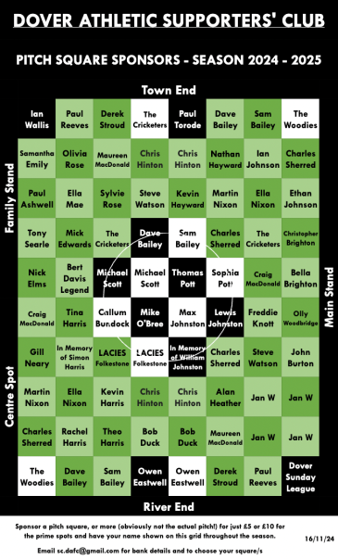**Pitch Squares 2024-25**

Pitch Squares went on sale this season featuring prime spots for the first time. The grid was filled by mid-November and has raised £500!

At the end of the season we will be matching the monies received (£500) and donating a total of £1,000 to the football club. **We will also be giving away a prize to one of the lucky participants, so keep your eyes peeled!**

An up to date grid can always be seen on our website www.dafcsc.co.uk and you can also see the grid with your selected name/square in the Match Day Programme.

**Fixture Update**

**Details of our Remaining Fixtures, All of our Results including Goal Scorers, Attendances and Match Highlights and a Table of our Top Goal Scorers can be seen on our excellent** **revamped website www.dafcsc/fixtures.co.uk** our remaining fixtures shown below may be subject to change. Any changes will be shown on our website.

|  |  |  |  |  |  |
| --- | --- | --- | --- | --- | --- |
|  |  | Saturday | 15th February | **H** | Whitehawk |
| **Kent Senior Cup - Semi-Final** | | Tuesday | 18th February | **A** | Welling United |
|  |  | Saturday | 22nd February | **H** | Chatham Town |
|  |  | Saturday | 1st March | **A** | Canvey Island |
|  |  | Saturday | 8th March | **H** | Bowers & Pitsea |
|  |  | Saturday | 15th March | **A** | Cray Valley PM |
| **Non-League Day** | | Saturday | 22nd March | **H** | Dulwich Hamlet |
|  |  | Saturday | 29th March | **A** | Cray Wanderers |
|  |  | Saturday | 5th April | **H** | Cheshunt |
|  |  | Saturday | 12th April | **H** | Hendon |
|  |  | Friday | 18th April | **A** | Dartford |
|  |  | Monday | 21st April | **H** | Hastings United |
|  |  | Saturday | 26th April | **A** | Chichester City |

All kick off times 3pm except Welling which is 7.45pm.

Standings after Wingate & Finchley away (8th February) can be seen below. This currently sees the team in 4th position.

|  |  |  |  |  |  |  |  |  |
| --- | --- | --- | --- | --- | --- | --- | --- | --- |
|  | **P** | **W** | **D** | **L** | **F** | **A** | **GD** | **PTS** |
| **Home** | 14 | 6 | 2 | 6 | 29 | 22 | 7 | 20 |
| **Away** | 16 | 11 | 3 | 2 | 39 | 14 | 25 | 36 |
| **Overall** | 30 | 17 | 5 | 8 | 68 | 36 | 32 | 56 |

**Important Membership Informatiom**

A reminder for our members who travel to away games - if you don’t travel on our coaches you can still vote for your Man of the Match.

You need to email your vote to sc.dafc@gmail.com within 24 hrs of the game, quoting your name and membership number.

**Youth Membership**

As well as the individual autograph cards that have been produced by the football club this season, we have been sending birthday cards to our youth members.

**Coach Travel**

So far this season, we have successfully run coaches to every away game except Folkestone, this for obvious reasons, wasn’t needed.

The team's away success has also been a key part of the coaches running.

We are currently taking bookings for Welling & Canvey Island.

**Please book your seats asap as they will be on a first come first served basis**

Britannia have now added two 55 seat coaches to their fleet, this will make it easier for the Supporters Club to upgrade to a larger coach if necessary.

**Events**



Our next **Quiz Night** will be on the 28th March, 7:30 for 8pm start in the Centre Spot.

Entry will be £3.00 per person with a maximum of 8 on a team. To enter a team, please email [sc.dafc@gmail.com](mailto:sc.dafc@gmail.com) or speak to a committee member.

Our **New Year Raffle** proved to be a great success raising £746 which was shared 50/50 with the Community Trust. A big thank you goes to everyone who donated prizes or bought tickets.

**Race Night** returned to the Cricketers in early February, raising

£227 for the Supporters’ Club funds. This popular event was another huge success with all races, horses and jockeys sold out before the night. There were some winners, some losers, but a good time was had by all!

**A special thank you goes to the individuals and companies who sponsored the eight races including The Cricketers, Britannia Coaches, Choose Leisure and Kayleigh’s Driving School.**

It’s fast approaching the business end of the season so it’s time to start thinking about the **End of Season Awards.** No date has yet been fixed as it’s more than likely we may be in the play offs?!

**AGM**

It’s that time of the year again! Our Annual General Meeting will be held in the Centre Spot on Saturday 8th March at 2pm before the Bowers & Pitsea game. Full details are enclosed with this newsletter, please attend if possible.

**Your Current Committee**

Since our last Newsletter we have lost one committee member. Lee Sansum decided to step down at the end of January after many years on the committee in the capacity as Chairman. We thank him for all his hard work and input and wish him well.

**The current Committee is: Mike Wood (Acting Chair), Derek Stroud (Secretary), and Paul Reeves (Treasurer), Craig MacDonald (Membership Secretary) Kirsty Noble (Social Media/Community Officer), Richard Reynolds (Club Liaison Officer), Vikki Pawley (Committee).**

**COYW**